**Lesson 16 – Finite State Machines (FSM) - Analysis**

**State Machine:**

1. Description
2. State Transition Diagram
3. State Transition Table & Output Table
4. Next State and Output State Equations
5. Schematic

**Slide Questions:**

**1)**

**2)**

**3) ${D1}^{*}=$**

**4) $Next State=$ $Output (Y)=$**

**5)**

**6)**

**7)**

**8) a)**

**b)**

**c)**

**9)**

**10)**

**Finite State Machine (FSM) Analysis – Joe Homeowner’s Garage door Opener:**

**Step 4) Schematic**

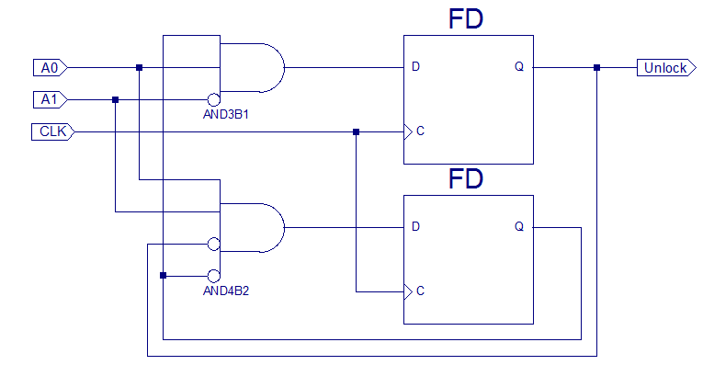

|  |  |  |  |  |  |  |
| --- | --- | --- | --- | --- | --- | --- |
| Next State Table: | | | | | |  |
| Current State | | Inputs | | Next  State | | Next State Name |
| S1 | S0 | A1 | A0 | S1* | S0* |
|  |  |  |  |  |  |  |
|  |  |  |  |  |  |  |
|  |  |  |  |  |  |  |
|  |  |  |  |  |  |  |
|  |  |  |  |  |  |  |
|  |  |  |  |  |  |  |
|  |  |  |  |  |  |  |
|  |  |  |  |  |  |  |
|  |  |  |  |  |  |  |
|  |  |  |  |  |  |  |
|  |  |  |  |  |  |  |
|  |  |  |  |  |  |  |
|  |  |  |  |  |  |  |
|  |  |  |  |  |  |  |
|  |  |  |  |  |  |  |
|  |  |  |  |  |  |  |

**Step 3) Next State and Output State Equations**

**Next State Equations**

**Output Equation:**

**Step 2) State Transition Table & Output Table**

|  |  |  |  |
| --- | --- | --- | --- |
| Output Table | | | |
| Current State | | Output | State Name |
| S1 | S0 | Unlock |  |
|  |  |  |  |
|  |  |  |  |
|  |  |  |  |
|  |  |  |  |

**Step 1) State Transition Diagram**

**Step 0) Description**

**What is the Door combination?**

**Step 4) Schematic**

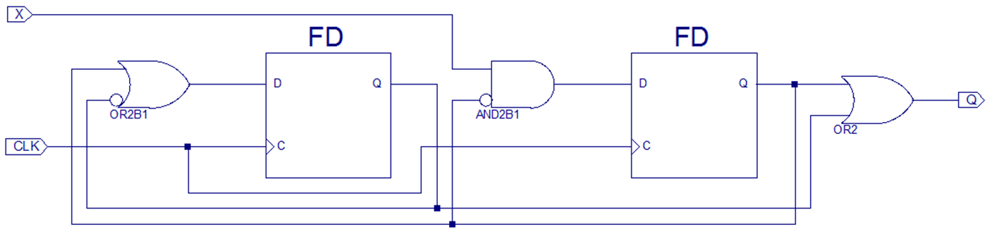

|  |  |  |  |  |  |
| --- | --- | --- | --- | --- | --- |
| Next State Table: | | | | | |
| Current State | | Inputs | Next  State | | Next State |
| S1 | S0 | X | S1* | S0* | Name |
|  |  |  |  |  |  |
|  |  |  |  |  |  |
|  |  |  |  |  |  |
|  |  |  |  |  |  |
|  |  |  |  |  |  |
|  |  |  |  |  |  |
|  |  |  |  |  |  |
|  |  |  |  |  |  |

**Step 3) Next State and Output State Equations**

**Next State Equations**

**Output Equation:**

**Step 2) State Transition Table & Output Table**

|  |  |  |  |
| --- | --- | --- | --- |
| Output Table | | | |
| Current State | | Output | State Name |
| S1 | S0 | Q |  |
|  |  |  |  |
|  |  |  |  |
|  |  |  |  |
|  |  |  |  |

**Step 1) State Transition Diagram**

**Step 0) Description**